NEW ZEALANDERS TO HELP MAP ASTEROID’S SHAPE

Introduction

Hundreds of astronomers and members of the public in Australia and New Zealand are being asked to assist astronomers with a rare astronomical event on Tuesday evening (June 24). Shortly after 10.30 pm, residents of the northern South Island will have the chance to see the asteroid Alkeste pass in front of the bright star beta in the constellation of Virgo (the Virgin), blocking the star’s light for up to 4 seconds..

Asteroids are rocky bodies which orbit the sun between Mars and Jupiter. While some are hundreds of kilometres across, many are thought to measure only a few tens of kilometres. However because they are so far away their size is difficult to measure, and so astronomers must rely on rare occasions (called occultations) when the asteroid passes in front of a background star. Because astronomers know how fast the asteroid is moving, if they can also record how long the star’s light is obscured it is easy to work out the diameter and shape of the asteroid.

Because it is very rare for an asteroid to pass in front of such a bright star the general public is being asked to participate by watching, recording and reporting what they see (or don’t see) from their own backyard. If you can see the faint fifth star of the Southern Cross in the sky (the constellation on the New Zealand flag), then your location is dark enough to be able to potentially witness the event.

Will I be able to see the event?

The shadow of Alkeste will cross onto the South Island from the west, covering an area between about Harihari and Greymouth, with Hokitika in the centre of the shadow. In only a few seconds it will sweep across the Alps, and then pass off New Zealand between about Hanmer Springs and regions north of Christchurch. Those in the central part of the shadow are almost certain to see the star wink out, while it is possible that observers in Kaikoura and central Christchurch may also see the event. (The black lines on the map show the region over which the event is expected to be visible. The red lines show the expected region should there be a small uncertainty in the path).

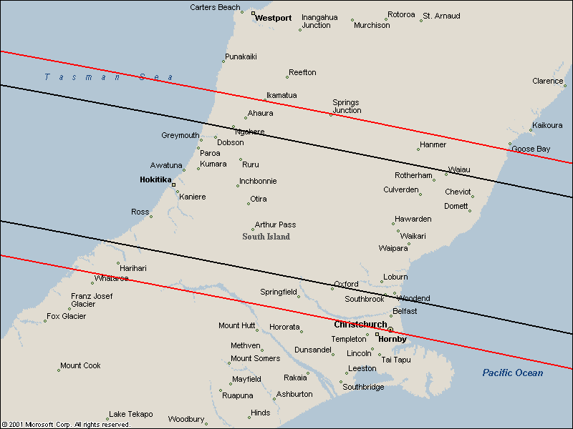
How and when should I record the event?

Skygazers should be able to see Tuesday’s event from their backyards by simply using their eyes (so long as the sky is dark enough to clearly see the star). However it is much better is to use binoculars, held very steady (for example, on a tripod), or a small telescope. Better still, those with very sensitive low-light home video cameras may be able to record the occultation.

Sometime between 10:35 pm and 10:40pm (but most likely just after 10:37pm), the star beta Virginis will suddenly disappear as the faint asteroid blocks it from view. Anywhere from an instant to a few seconds later it will then suddenly reappear as the faint asteroid moves away. The star chart below shows how to find the star beta Virginis, which is circled. It will be just over 1 handspan above the northwestern horizon, and somewhat lower in the sky than the bright star Spica. To see the star clearly you should observe from a dark location and let your eyes get adjusted to the darkness for at least 10 minutes beforehand. It is also important to practise finding the star quite some time before the event.

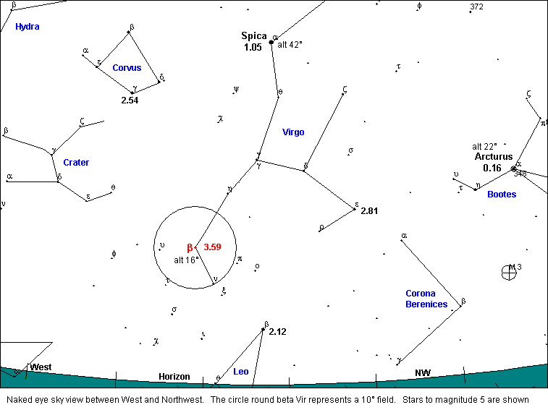

How can I help?

The simplest observation for the whole family is to see whether the star disappears or not. If it does, the shadow of Alkeste passed across you. If it does not, then the shadow passed elsewhere - but your observation is still very important.

The most valuable observations will be those in which exactly how long the star disappeared for is recorded. The best way to do this is to take an ordinary cassette recorder and a radio outside. Tune the radio to National Radio on 675 kHz (Christchurch), 567 kHz (Wellington) 1116 kHZ (Nelson) or 95.5 FM (Greymouth), and start the tape recording before 10:35pm. Leave the radio (which is used as a timing reference) playing in the background so it is picked up on the tape. The instant you see the star disappear, shout “GONE” into the tape recorder’s microphone, then “BACK” when the star reappears soon after. These events will occur very suddenly so you must be prepared. You should leave the tape continuing to record until at least 10:40 pm.

If using a low-light home video camera first make sure that you can clearly record the correct star. Start recording before 10:35pm and position the radio close to the audio microphone of the video camera. Leave the tape recording until at least 10:40 pm. The advantage of using a video camera is that the tape can be replayed later and the exact duration of the disappearance measured much more accurately.

What to Report

The Royal Astronomical Society of New Zealand will be pleased to receive reports from anyone, whether the star was seen to disappear or not. Reports should include

- Your name, street address and phone number, and the exact details of the location where you observed.
- Did you use your naked eye, binoculars or a video camera?
- Did you see the star disappear?
- If so, please send us your audio or videotape for analysis.

Note: Any tapes you send us will be returned, unless you indicate that is not necessary.

Please send your reports to:

Graham Blow
Royal Astronomical Society of New Zealand
P.O. Box 2241
Wellington

Email: Graham.Blow@actrix.gen.nz
Ph: (04) 479-2504

Further detailed information about this rare event is available at:
http://occsec.wellington.net.nz/planet/2003/030624u.htm

