R.A.S.N.Z. OCCULTATION SECTION

REPORT TO COUNCIL - 2003

Minor Planet Occultations

The main focus of the Section’s activities continues to be occultations of stars by minor planets. This year, some 19 occultations were observed, up from 13 in 2002, the increase reflecting both the greater accuracy of the updated predictions and (in some regions) the increased interest in monitoring these events.

Occultation events observed were:

Date | Planet | Chords observed
Feb 14 | (23) Thalia | Possible occultation of ca. 4 seconds duration (Albert Brakel)
Apr 21 | (210) Isabella | 3 chords (Alan & Pam Gilmore, Patrick Purcell, Robert Price):  The photoelectric observation at Mt John clearly shows that the star TYC 6154-00401-1 is double. This data, together with the chords observed across opposing sides of the asteroid, yields a fit of 85 x 53 km for (210) Isabella and a separation of 5.4 milliarcseconds in PA 81.9 degrees for the components of the double.
Jun 24 | (124) Alkeste | 20 chords observed from Australia and New Zealand – see notes below
Jun 28 | (709) Fringilla | 1 chord (John Broughton, CCD drift-scan method)
Jul 14 | (100) Hekate | 1 chord (Michael Mattiazzo)
Jul 15 | (372) Palma | 1 chord (Ray Pickard)
Jul 19 | (976) Benjamina | 11 chords – see notes below
Jul 20 | (165) Loreley | 1 chord (John Broughton, CCD drift-scan method)
Jul 24 | (690) Wratislavia | 2 chords (John Broughton, CCD drift-scan; Peter Anderson)
Jul 27 | (27) Euterpe | 1 chord (John Broughton, CCD drift-scan method)
Aug 6 | (205) Martha | 1 chord (Peter Litwiniuk)
Aug 10 | (481) Emita | 3 chords (Albert Brakel, Grant Murphy, Patrick Purcell)
Aug 24 | (21) Lutetia | 1 chord (John Broughton, CCD drift-scan method)
Aug 30 | (503) Evelyn | 1 chord (David Brock)
Sep 1 | (230) Athamantis | 1 chord (David Higgins)
Sep 18 | (336) Lacadiera | 1 chord (Stephen Kerr)
Sep 29 | (259) Aletheia | 3 chords (Alan & Pam Gilmore, Brian Loader, Euan Mason)
Oct 18 | (219) Thusnelda | 3 chords (Graham Blow, Chris Picking, Richard Dodd)
Oct 20 | (99) Dike | 1 chord (David Herald)

Notes to the Table:

The two stand out events for the year were the June 24 occultation of mag 2.9 Beta Virginis by (124) Alkeste, and the July 19 event involving (976) Benjamina. Both events involved observers from both sides of the Tasman, with the Alkeste event giving us 20 chords covering three-quarters of the asteroid – easily an Australasian record.

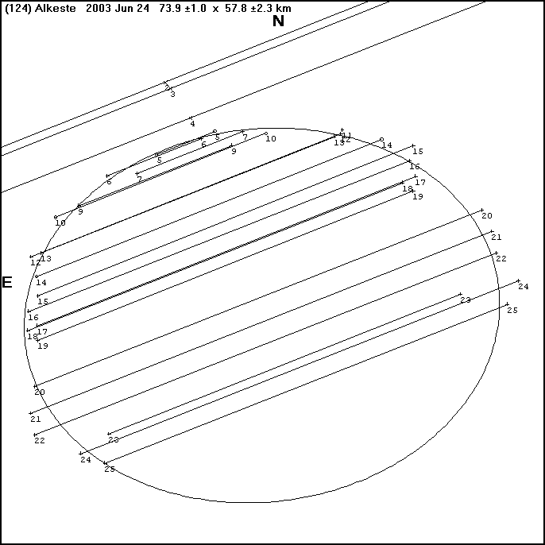

The Alkeste result clearly shows what can be achieved with co-operating observers. It also shows the non-spherical outline of Alkeste, while also underscoring the importance of non-visual (video, photoelectric) observations which are independent of visual observers’ reaction times (These account for some of the different chord lengths in the diagram). It is clear that the accuracy of future observations will be substantially enhanced if observers are further encouraged into the use of video, CCD “drift-scan” and photometric techniques.

The year was also notable for the pioneering work of John Broughton in Reedy Creek, Queensland, who has developed the CCD “drift-scan” technique into a unique, efficient and highly accurate tool for observing occultations. John’s patience was rewarded with no less than 5 positive events during the year.

With the introduction of the 2UCAC catalogue towards the end of the year the accuracy of minor planet occultation predictions has again increased, with paths now regularly predicted to within one track width and, for some events, to within 1/8th path width. Together with the introduction of a system of regional co-ordinators it is hoped that more people will continue to be attracted to this type of observing.

Other Occultations

The Section has continued to co-ordinate other forms of occultation work, with eleven observers (same as for 2002) reporting 474 (662 in 2002) total lunar occultation timings, as well as 5 grazing occultation expeditions. With the emphasis put on minor planet events in recent years it is concerning that so few observers are now participating in total and grazing occultations, especially since these provide such a good training ground for observers.

Jovian Satellite Eclipses

The Section’s programme of observing and recording the eclipses of Jupiter’s satellites also continued during 2003 under the excellent direction of Brian Loader. (Enquiries concerning this aspect of the Section’s work should be directed to 14 Craigieburn Street, Darfield, 8172, New Zealand, email: palbrl@caverock.net.nz). Brian has provided the following summary of observations from the 2001/02 apparition (the last apparition for which complete data was available before this report):

For the 2001/2 apparition the total number of observations reduced was down to 80 as against 99 for the previous apparition. These were submitted by 9 observers in Australia, New Zealand and Germany as against 14 previously. The northerly declination of Jupiter, the fact that it was a southern summer apparition with opposition on the last day of 2001 and, at least in New Zealand, continued poor observing weather, must all help account for the continuing decline in numbers of observations. However it does seem to also reflect a fall in the interest in this programme.

Observations have continued for 2002/03, but it looks as if in reduced numbers again. I think that apart from one or two stalwarts, interest is petering out, and once again I am thinking of winding the programme up rather than just let it die.

We no longer get Dr Jay Lieske's (JPL) predictions, and are now using predictions based on the G5 ephemerides of the Galilean satellites (Arlot 1982), provided by William Thuillot of the Institute de Mecanique Celeste, Paris. It looks as if the Astronomical Almanac has reverted to these as well (I think they used Lieske at one time). From our results it looks as if Liekse's predictions were the more accurate.

I have been experimenting, weather permitting, using the video system on Jovian Satellite eclipses as well as occultations. It does seem that the video will follow a satellite more deeply into the eclipse than can be done by eye, provided Jupiter is almost completely out of the camera field of view.

Other Activities

During the year the Section published four News Circulars totalling 104 pages – substantially more pages than in the previous year. These listed observations of minor planet occultations and appulses together with reports of total and grazing lunar occultations. They also contained items of more general interest to occultation observers. The Circulars were very capably edited by Brian and Pauline Loader of Darfield who, after almost 8 years in the position, stood down from the editorship role after the first Circular of 2004. In addition four Circulars containing predictions of 150 (142 in 2002) appulses of minor planets to stars were published.

The Section’s website remains its most important asset and has become an indispensible tool for providing timely information to our members and others. Predictions for a substantially greater number of minor planet occultations than appear in the printed Circulars are available on the site, and updated paths are posted on a weekly basis. During the year David Higgins of Canberra came on board to assist with preparing and posting updates, as well as preparing new predictions not published in paper form. Stephen Kerr of Rockhampton has continued the digital annotation of Edwin Goffin’s minor planet prediction charts prior to their paper and on-line publication.

The Australian time signal station VNG closed at the end of 2002 and this has led to ongoing problems for some of our Australian observers who no longer have access to accurate time signals. Several groups have discussed plans to produce small, low-cost and portable timebase units based on surplus GPS chips, but although some prototypes have been developed, none of these units is at present in production. It is generally agreed that the solution to our timing problems will only come when someone is prepared to mass-produce GPS-based units such as these.

It is my pleasure to thank Brian and Pauline Loader, Stephen Kerr and David Higgins for their continued assistance and support of the Section - without their work the Section would not be able to offer the service that it does. In addition we continue to rely on the asteroid update service provided by Steve Preston in Washington State. Alfred Kruijshoop also continues to provide invaluable assistance in overseeing our total and grazing occultation work.

Finally, I wish to thank all our observers who continue to entrust us with their valuable data.

Graham L. Blow
Director

P.O. Box 2241, Wellington
Email: Graham.Blow@actrix.gen.nz
Website: http://occsec.wellington.net.nz/

